

**Portfolio Enhancing: A Sectoral Approach**

A DISSERTATION SUBMITTED TO

SVKM’S NMIMS (DEEMED TO BE UNIVERSITY)

IN PARTIAL FULFILLMENT FOR THE DEGREE OF

**MASTERS OF SCIENCE**

**IN**

**STATISTICS AND DATA SCIENCE**

BY

**Piyush Korake 86062300069**

**Partha Lalit 86062300039**

**Heeta Parmar 86062300012**

**Parth Sante 86062300067**

**Aniruddha Shelke 86062300008**

**Sakshi Shinde 86062300041**

UNDER THE SUPERVISION OF

Dr Pradnya Khandeparkar

NILKAMAL SCHOOL OF MATHEMATICS, APPLIED STATISTICS AND ANALYTICS

SVKM’s Narsee Monjee Institute of Management Studies

(Deemed-To-Be-University)

V.L. Mehta Rd, Vile Parle (West), Mumbai – 400056

November 2023

**ACKNOWLEDGEMENT**

We, the students of NSoMASA, MSc Statistics and Data Science, Semester 2, acknowledge our gratitude to all the individuals associated with this project.

We would like to pay our respect to our mentor, Dr. Pradnya Khandeparkar, who has imparted us with knowledge, inspiration, and motivation throughout the course of the project. It would not have been possible for us to complete the same without her sincere and affectionate help.

We would also like to thank our professor, Mahesh Bansal for guiding us and keeping us motivated from the start till the end of this project. His knowledge in the financial domain aided us in the project alongside getting to learn many concepts of the domain.

Further, we would like to thank SVKM's Library for allowing us to access the portal through which we got the required research papers, datasets, and study material needed for the project.

At last, we also thank our faculty, parents, and friends who contributed to some extent to complete the same.

**INDEX**

1 Abstract: 3

2 Introduction: 4

3 Literature Review: 5

4 Rationale: 6

5 Aims & Objectives: 7

6 Data Preparation 8

6.1 About The Data: 8

6.2 Data Cleaning & Pre-Processing: 8

7 Methodology 9

8 Results & Discussion 15

9 Summary & Conclusion 21

10 References 22

11 Appendix 23

# Abstract:

“Investing in stock market is subject to market risks” so the minimising the risk seems a way out. Investing into various assets creates a portfolio and diversification leads to minimising the risk. Building a successful portfolio means imbibing various techniques together and adhering to a discipline. In this project, a massive 10 yearlong financial data of 500 large cap companies have been taken under to carefully study different statistical models. These models help in better allocation of weights to the assets, further aiding in making the decision to invest in a particular asset. Since no one had analysed the portfolio on a sector basis, this project introduces a sectoral approach in enhancing the portfolio returns. The statistical models like, Mean-Variance model, Conditional Value-at-Risk model help in providing portfolios with a targeted minimum risk and gradually good returns. These models have been comparatively studied along. After generating the portfolios, techniques like Discrete Allocation and Portfolio Rebalancing have been applied to manage the risk which arises due to the change in the stock market movements of the assets over the time.

# Introduction:

In a fast-paced world of rising economy, the fundamental unit of money is of the utmost important. Value of the hard-earned money increases multi-fold, so when it comes investing in the stock market, people hesitate and invest only after a thorough consideration backed by an expert opinion or calculations. This task could be very tedious and time consuming. Managing the loss and tackling the risks will easily make people turn away from this interesting field based on economy. Stock Market investment is still considered a sort of taboo in India. To solve this problem and make the money-investing easy such that one gets maximum returns, we have introduced a sectorial approach for enhancing the portfolio, in our project.

After extensive collection of the Indian stock market data and a careful study of the indicators, we addressed the need to go for a sector-wise approach. A massive 10 years of stock data of 500 companies was considered. The data was cleaned such that only the companies which were listed in the stock market for 2465 days were considered for the analysis. So, we were left with 389 large cap companies. This data was classified into 11 sectors such Industries, Utilities, etc for analysing based on sector. After feature engineering, the data was ready to be trained and tested on models. Assigning weights to the sector and further to the companies of that sector, different models were used.

The Mean-Variance model is used to generate portfolio with maximum return for a specified risk, or the minimum risk for a specified return (Chen et al., 2021). The MV model proposed by Markowitz lays the basis for portfolio selection. In this model, the investment return and risk are quantified by expected return and variance, respectively. Rational investors always pursue the lowest risk under a specific expected return or the highest return under a particular risk, choosing an appropriate portfolio to maximize expected utility. The MV model aims to make a trade-off between maximizing returns and minimizing risks.

Portfolio enhancing concerns the selection of optimal projects to mitigate and manage off-taker’s exposure to risk. The CVaR measure introduced by Rockafellar and Uryasev is used in various portfolio optimization problems for managing risk (Tyrrell Rockafellar & Uryasev, 2000). This method has been used to generate portfolios with risk mitigated.

(Erik & Pedersen, 2014) uses Monte Carlo simulation of a simple equity growth model with resampling of historical financial data to estimate the probability distributions of the future equity, earnings, and payouts of companies. So, we used this technique for maximum Sharpe ratio allocation with risk free rate to be 0.1, with 20,000 portfolios simulated.

After concluding which model/technique works the best suiting to the investor, discrete allocation was done to diversify the portfolio which results in distributing the risk all over the different assets. This concept was used in (Sengupta et al., 2024) for optimal stock allocation.

Once the portfolio is generated, the problem which arises is the fluctuation in the stock market which leads to changes in values of the stocks. To tackle this problem, the technique of portfolio rebalancing is carried out. Designing an effective portfolio rebalancing optimization model for N assets involves finding the right balance between risk and return to meet the investor’s specific objectives (Sahu & Kumar, 2024).

# Literature Review:

The study from (Chen et al., 2021) introduced a novel portfolio construction method combining XGBoost, Improved Firefly Algorithm (IFA), and Mean-Variance (MV) model. IFAXGBoost+MV outperformed alternative models, showing superior return characteristics and risk metrics, with the highest cumulative return. The approach demonstrated effectiveness in optimizing portfolio selection and balancing return-risk ratio.

(Hamdi et al., 2022) reviews recent studies on portfolio optimization, emphasizing the use of CVaR and DEA models. Researchers have explored CVaR as a risk measure in portfolio selection, comparing it with other popular models like Markowitz and VaR Studies have integrated CVaR with innovative approaches like PROMETHEE II, Bayesian optimization, and DEA models for efficient portfolio selection. The literature highlights the significance of CVaR in mitigating financial risk and optimizing portfolios for better returns.

(Shadabfar & Cheng, 2020) discusses probabilistic portfolio optimization, stock market indices, and financial engineering concepts, emphasizing the use of Monte Carlo methods for robust algorithm development and evaluation. It highlights the significance of Markowitz's portfolio theory and its evolution in financial engineering practices.

(Sengupta et al., 2024) discusses the weight allocation in portfolios based on attributes like expected return, risk, and volume. It compares the performance of Modern Portfolio Theory (MPT) and Hierarchical Risk Parity (HRP) models for weight distribution. The study highlights the importance of considering factors like beta factor and market fluctuations for effective stock selection and allocation in portfolios.  
(Erik & Pedersen, 2014) Monte Carlo simulation is utilized in the equity growth model by Pedersen to estimate the probability distribution of outcomes when deriving the future distribution of asset returns. It allows for modelling arbitrary probability distributions, especially for rare events, when the distribution cannot be derived analytically due to complexity or non-simple stochastic variables. The simulation involves steps like loading historical financial data, determining the number of iterations, setting parameters for normalization, and sampling data synchronized between companies to model equity growth.

(Sahu & Kumar, 2024) The paper explores portfolio rebalancing optimization using Support Vector Machines (SVM) in the context of financial markets. It addresses the gap in integrating SVM techniques into dynamic portfolio rebalancing strategies, emphasizing real-time market fluctuations and the balance between risk and return. The study aims to develop robust and sophisticated SVM-driven portfolio rebalancing models to enhance investment decision-making. Previous research has advanced portfolio selection methodologies, highlighting the evolution of portfolio theory to adapt to changing market dynamics and improve portfolio construction and management strategies.

# Rationale:

The rationale for the project lies in addressing the common challenges faced by individuals when investing in the stock market, such as complexity, risks, returns on investments and the need for expert guidance. By introducing a sectorial approach to portfolio management, the project aims to simplify the investment process and maximize returns for investors. This helps the investors like how an expert would do.

The extensive analysis of Indian stock market data and the application of models like the Mean-Variance model and CVaR model demonstrate a strategic approach to optimize portfolio selection and manage risks effectively. The incorporation of techniques like Monte Carlo simulation and discrete allocation further enhances the project's methodology, ensuring diversified and balanced portfolios. Lastly, emphasizing portfolio rebalancing optimization highlights the project's commitment to maintaining the desired risk-return balance tailored to individual investor objectives. More the people become financially independent and smart, more the progress, a nation will do.

# Aims & Objectives:

**Aims:**

1. To simplify stock market investment for individuals in India by introducing a sectorial approach to portfolio enhancement.

2. To address the hesitation and perceived risks associated with stock market investment by providing a structured and data-driven strategy.

3. To maximize returns and manage risks effectively through a comprehensive analysis of 10 years of stock data from 500 companies in the Indian market.

4. To promote financial literacy and empower individuals to make informed investment decisions in the dynamic economic landscape of India.

**Objectives:**

1. Conduct an extensive collection of Indian stock market data to build a robust foundation for analysis.

2. To allocate weights to each asset, from the 11 sectors, using different statistical models.

3. To study different models for a comparative study, namely, Mean-Variance Model and Efficient CVaR. Define appropriate metrics for comparison such as Sharpe ratio, Expected Annual Return, Annual Volatility.

4. Discrete Allocation:

To decide on the total budget for the portfolio and ensure that the portfolio is well-diversified across different sectors to reduce risk.

5. Portfolio Rebalancing:

To construct a rebalancing portfolio (annually) using the best-performing model.

# Data Preparation

## About The Data:

The data was web scrapped from yahoo finance into python using libraries like BeautifulSoup and yfinance. It is financial data containing the stock prices of India’s 500 large cap companies for 10 years, starting from 1 Jan 2014 to 1 Jan 2023. It consists of columns like open, high, low, close, Adj. close, volume along with the names of the companies.

## Data Cleaning & Pre-Processing:

While inspecting the data, it came to our understanding that not all companies were listed in the stock market for the same amount of time. This creates a discrepancy while making a meaningful insight about the data. So, to study the financial behaviour neatly, we considered only those who have been in the market for 2465 over the period of 10 years. This left us with still a significant count of 389 companies.

Further, for a sectoral approach, we classified the companies into 11 sectors like Energy, Utilities, Industrials, etc. So, another column was added to the data, namely, “Sector.” This got accompanied by a further division of the companies into the type of industry they fall in. For e.g., Reliance company limited falls under the industry of Oil & Gas Refining & Marketing. Thus, another column named “Industry” was added.

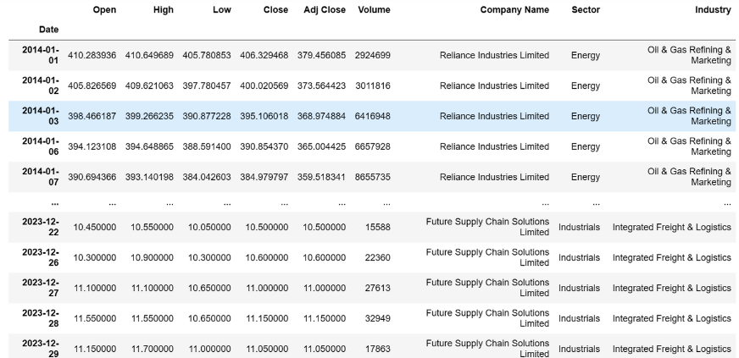

After this preprocessing of the data, analysis part was carried out.

# Methodology

**Mean-Variance Portfolio Theory:**

Portfolio - Collection of investments (equities, bonds, T-bills, derivative, etc).It is constructed for the purpose of diversification. Including number of assets will reduce the risk will keeping the performance intact. The financial instruments performance is majorly uncertain so choosing an optimal mix of assets is a problem. To solve the problem of optimal portfolio, Harry Markowitz in the 1950 provided mean-variance analysis (M-V analysis), it is also popularly referred as modern portfolio theory.

Two criteria need to be taken into consideration while making a portfolio choice.

1) The expected portfolio returns.

2) Variance of the portfolio return (risk proxy)

Expected return higher always preferred and lower variance always preferred. Mean-variance framework is the first proposed model of the reward-risk type. The expected portfolio return is used as a measure of reward and the variance of portfolio return indicates how well-diversified the portfolio is.

The main principle behind M-V analysis can be summarized in two ways:

From all feasible portfolios with a given lower bound on the expected performance, find the ones that have the minimum variance (i.e., the maximally diversified ones).

From all feasible portfolios with a given upper bound on the variance of portfolio return (i.e., with an upper bound on the diversification level), find the ones that have maximum expected performance.

In simple words - Mean-Variance portfolio theory specifies a method for an investor to construct a portfolio that gives the maximum return for a specified risk, or the minimum risk for a specified return.

We can find two optimisation problems behind the formulations of the main principle of M-V analysis.

● Suppose that the investment universe consists of n financial assets.

● Denote the assets returns by the vector X′ = (X1, . . . ,Xn) in which Xi stands

for the return on the ith asset.

● The returns are random and their mean is denoted by μ ′ = (μ1, . . . , μn)

where μi = E(Xi).

● The dependence will be described by the covariances. Between the ith and

the jth return it is denoted by

σij = cov(Xi ,Xj) = E(Xi − μi)(Xj − μj).

Correlations, which are essentially scaled covariances, are a more useful concept to see the dependence between the stocks. The correlation between the random return of the X and the Y asset are computed by dividing the corresponding covariance by the product of the standard deviations of the two random returns,

Correlation = Cov(X,Y)/sd(x).sd(y)

● The correlation is always bounded in the interval [−1, 1].

● The closer it is to the boundaries, the stronger the dependence between the

two random variables.

●If correlation = 1, then the random variables are positively linearly dependent

(i.e., Xi = aXj + b, a > 0);

● If correlation = −1, they are negatively linearly dependent (i.e., Xi = aXj + b, a

< 0).

● If the two random variables are independent, then the covariance between

them is zero and so is the correlation.

The result of an investment decision is a portfolio, the composition of which is denoted by w ′ = (w1, . . . , wn), where wi is the portfolio weight corresponding to the ith instrument.

We will consider long-only strategies which means that all weights should be non-negative, wi ≥ 0, and should sum up to one,

w1 + w2 + . . . + wn = w ′e = 1. where e′ = (1, 1, . . . , 1).

These conditions will be set as constraints in the optimisation problem.

The return of a portfolio rp can be expressed by means of the weights and the returns of the assets,



Similarly, the expected portfolio return can be expressed by the vector of weights and expected assets returns,



Finally, the variance of portfolio returns can be expressed by means of portfolio weights and the covariances σij between the assets returns.

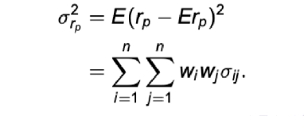

The covariances of all asset returns can be arranged in a matrix and can be expressed as



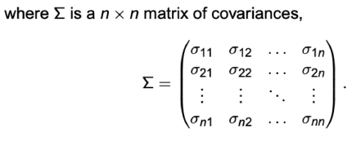

The optimisation problem behind the first formulation of the main principle of M-V analysis is



where w ≥ 0 means that all components of the vector are non-negative, wi ≥ 0, i = 1, n.

Similarly, the optimisation problem behind the second formulation of the principle is



**Markowitz’s Efficient Frontier**

For Two risky assets we can understand the efficient frontier with the help of the above diagram. In the y-axis it has the expected returns and, in the x-axis, it has the risk. All the points seen in the above diagram are the feasible portfolio but if any point which lies in the curve above the Global minimum variance portfolio is efficient because that point denotes the maximum return we can get with the given level of risk. The points( which denote the portfolio) lies inside the curve are the inferior because with the same level of risk we can get the portfolio with higher expected returns.

A portfolio is inefficient if the investor can find another portfolio with the same (or higher) expected return and lower variance, or the same (or lower) variance and higher expected return.

A portfolio is efficient if the investor cannot find a better one in the sense that it has either a higher expected return and the same (or lower) variance or a lower variance and the same (or higher) expected return.

That is, an efficient portfolio is one that is not inefficient. Thus, every portfolio – including those that consist of a single asset – is either efficient or inefficient.

Once the set of efficient portfolios has been identified all others can be ignored.

This is because an investor who is risk-averse and prefers more to less will never choose an inefficient portfolio. The set of efficient portfolios is known as the efficient frontier.

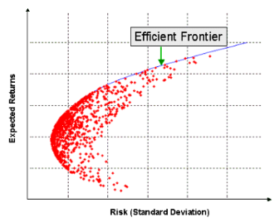

The hyperbola is referred to as the "Markowitz bullet", and its upward sloped portion is the efficient frontier if no risk-free asset is available.

**Conditional Value at Risk (CVaR):**

Conditional Value at Risk (CVaR), also known as the expected shortfall, is a risk assessment measure that quantifies the amount of tail risk an investment portfolio has.

CVaR is derived by taking a weighted average of the “extreme” losses in the tail of the distribution of possible returns, beyond the value at risk (VaR) cutoff point.

In other words, CVaR quantifies the expected losses that occur beyond the VaR breakpoint.

Uses:

Risk Assessment: CVaR is used to assess the risk associated with an investment portfolio.

Portfolio Optimization: It helps in effective risk management during portfolio optimization.

Stress Testing and Scenario Analysis: Investors use CVaR to prepare for potential extreme market events.

Formula:

CVaR values are derived from the calculation of VaR itself.

The formula for CVaR is simple once VaR has been calculated:

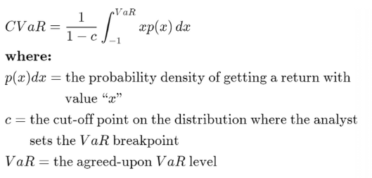

**Monte Carlo Simulation:**

Monte Carlo simulation is computer simulation of a stochastic model repeated numerous times to estimate the probability distribution of the outcome of the stochastic model. This is useful when the probability distribution is not possible to derive analytically, either because it is too complex or because the stochastic variables of the model are not from simple, well-behaved probability distributions. Monte Carlo simulation allows for arbitrary probability distributions so that very rare events can also be modelled.

The Monte Carlo method uses a random sampling of information to solve a statistical problem; while a simulation is a way to virtually demonstrate a strategy. The risk-free rate represents the return an investor can earn with zero risk.

Expected Weighted Return:

Weighted return of company = Wi × Ri

Weighted return of the portfolio =

Wi: Weight of the ith ticker within the whole portfolio.

Ri: Return of the ith security.



**Evaluation Metrics:**

1. **Sharpe Ratio:** Measure of risk-adjusted return. It is calculated as the difference between the

portfolio’s return and the risk-free rate, divided by the portfolio’s standard deviation.

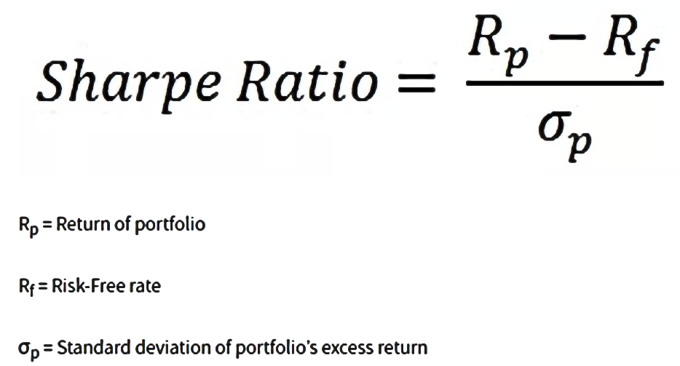

1. **Annualized Return:** It is the geometric average amount of money earned by an investment each year over a given period.



1. **Expected Volatility:** It is a statistical measure of the dispersion of returns for a given security or market index.



These evaluation metrics were used to check whether the model is giving results within the limits of the risks and returns as expected.

# Results & Discussion

**Mean Variance Model:**

Following were the results after using the MV Model:

The mean matrix :

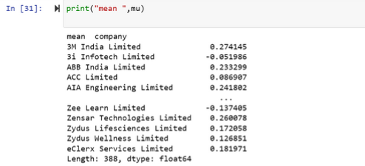

The Variance Matrix:

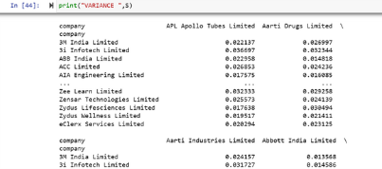

Following is the weight allocation on the company basis:

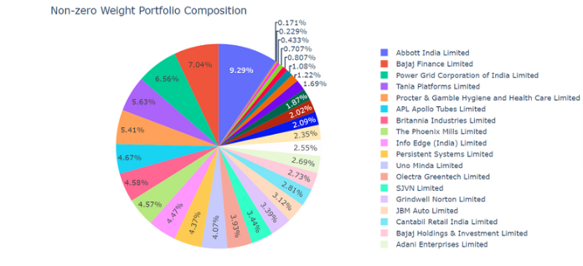

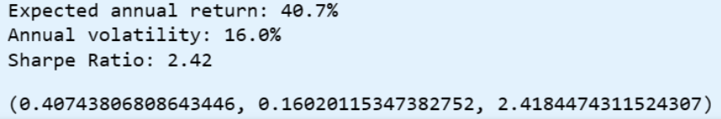**:**

Following is the weight allocation on the sector basis:

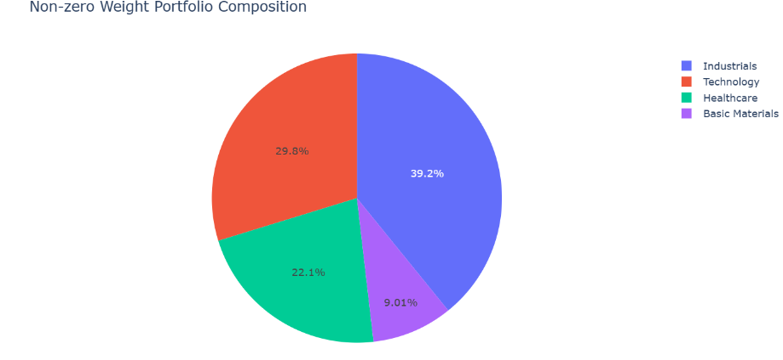

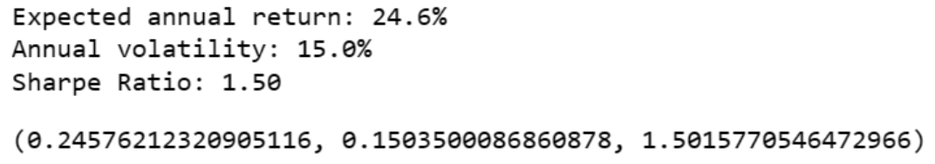

**Interpretations:**

Sector that stands out for maximum return with minimum risk is the Industrial Sector.

The model is working out efficiently as the Sharpe Ratio obtained for Company wise approach is 16.0% and according to standard rule the Sharpe ratio should be greater than equal to 15%.

**Conditional Value at Risk (CVaR):**

Following is the weight allocation on the company basis:

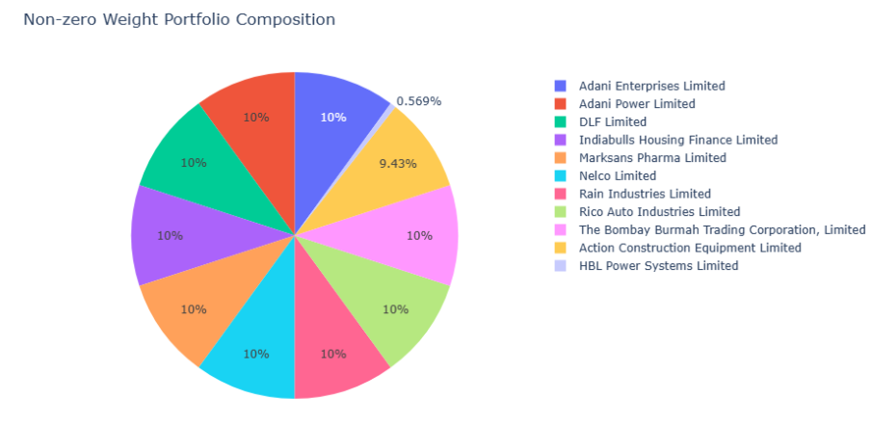

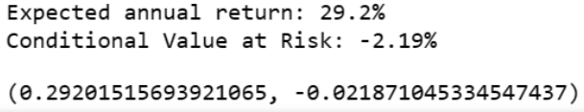

Following is the weight allocation on the sector basis:

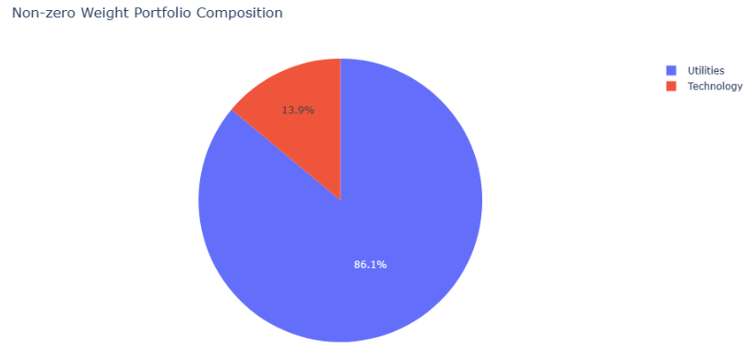

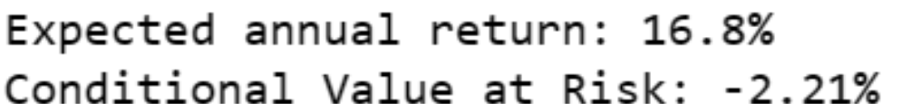

**Interpretations:**

The Sector with Minimum risk i.e. no risk is Utilities .

**Portfolio Models sectoral comparison:**

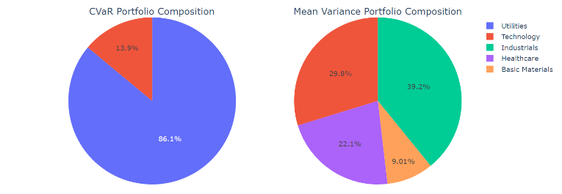

**Interpretations:**

For an investor to investing in short term should go by Mean Variance portfolio .

**Monte Carlo Simulation:**

Using the Monte Carlo Simulation, with parameters as follows:

No. of portfolios simulated = 20,000

Risk Free Rate = 0.1

Following is the allocation provided as the output:

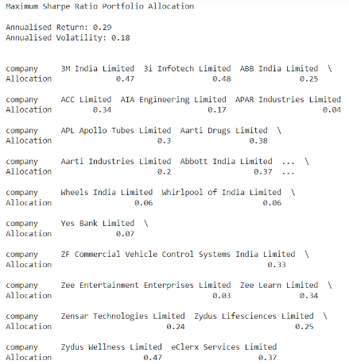

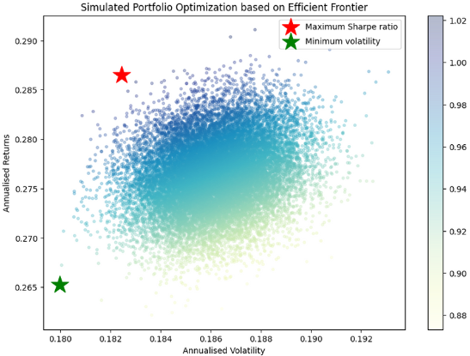

**Interpretations:**

The red star shows the portfolio with the maximum Sharpe ratio and the green star depicts the point with the minimum volatility.

**Discrete Allocation:**

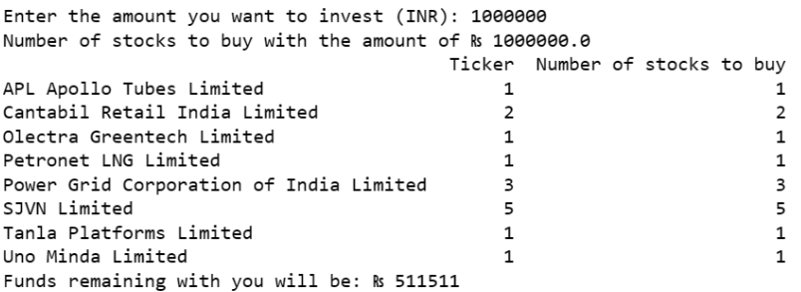

**Interpretations:**

This method gives you an idea to buy the total number of stocks for each company. It gives you the allocation based on the companies which will give you maximum return with minimum risk .and the remaining amount should be invested in risk free assets like mutual funds etc.

**Portfolio Rebalancing:**

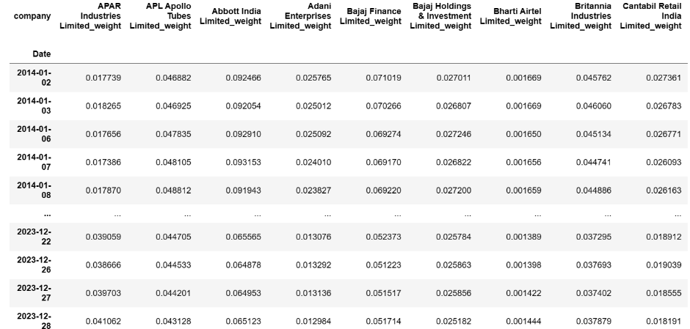

These are the allocations produced on the daily basis for the companies.

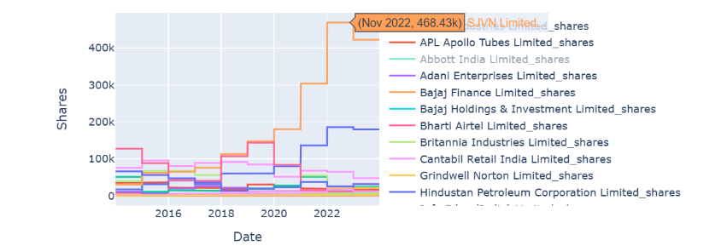

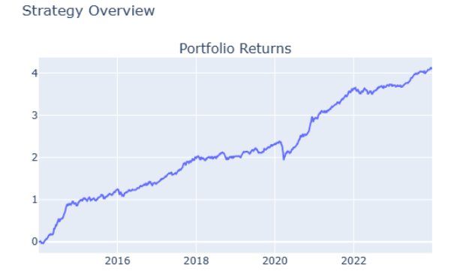

**Interpretations:**

The prices of SVJN Limited have increased over the period of 10 years and comparing it will the market situation now(2024) the prices are actually high .

# Summary & Conclusion

Thus, we were able to allocate weights according to the sector performance using methods like Mean-Variance model, Conditional Value-at-Risk and Monte Carlo Simulation. We also addressed the usefulness of the models in different use cases. By diversifying our portfolio using discrete allocation, risks are mitigated and rebalancing it gives the investor an annual information to tweak his investments and buying-selling of the stocks. Post analysis we can conclude the difference between the model.

Mean-Variance Model:

1. Focus :

- The Mean-Variance model primarily focuses on the mean (expected return) and variance (or standard deviation) of asset returns. It assumes that asset returns follow a normal distribution and that investors are risk-averse, aiming to maximize expected return while minimizing variance.

2. Risk Measure :

- Risk is measured by the variance or standard deviation of returns, representing the dispersion of returns around the mean. Higher variance indicates greater volatility and risk. The model assumes that risk can be adequately captured by the variability of returns.

3. Optimization :

- Portfolio optimization involves finding the combination of assets that maximizes the Sharpe ratio, which is the ratio of excess return to volatility (risk). The optimal portfolio lies on the efficient frontier, representing the set of portfolios with the highest expected return for a given level of risk.

4. Tail Risk Management :

- The Mean-Variance model does not explicitly address tail risk or the potential for extreme losses beyond a certain threshold. It focuses on the variability of returns around the mean and may not adequately capture extreme events.

5. Portfolio Characteristics :

- Portfolios optimized using the Mean-Variance model may lead to more aggressive allocations since they prioritize maximizing expected return. However, they may also be susceptible to higher levels of risk, especially during periods of market turbulence.

6. Implementation :

- The Mean-Variance model is relatively straightforward to implement, as it relies on simple calculations involving expected returns and covariance matrices. Many portfolio optimization tools and software packages are available to assist investors in constructing Mean-Variance efficient portfolios.

Conditional Value at Risk (CVaR) Model:

1. Focus :

- Unlike the Mean-Variance model, the CVaR model considers the entire distribution of returns rather than just the mean and variance. It emphasizes the tail of the distribution, where extreme events occur, and provides a more comprehensive measure of risk.

2. Risk Measure :

- Risk is measured by the Conditional Value at Risk (CVaR), also known as Expected Shortfall. CVaR represents the expected loss of the portfolio beyond a certain confidence level or threshold. It quantifies the average of all losses that exceed this threshold, providing a measure of downside risk.

3. Optimization :

- Portfolio optimization involves finding the combination of assets that minimizes CVaR subject to certain constraints. The optimal portfolio aims to minimize the expected loss beyond the specified confidence level, providing downside protection against extreme events.

4. Tail Risk Management :

- The CVaR model explicitly focuses on mitigating tail risk by considering the entire distribution of returns and minimizing the expected loss beyond a specified threshold. It provides investors with a more robust framework for managing extreme events and tail risks.

5. Portfolio Characteristics :

- Portfolios optimized using the CVaR model tend to be more conservative and risk-averse since they prioritize minimizing the risk of extreme losses. They may allocate more heavily to assets with lower tail risk, such as high-quality bonds or defensive stocks.

6. Implementation:

- Implementing the CVaR model may require more sophisticated techniques and specialized tools compared to the Mean-Variance model. Estimating the entire distribution of returns and calculating CVaR can be computationally intensive, requiring advanced modelling techniques.

In summary, while both the Mean-Variance and CVaR models are used in portfolio optimization, they differ in their objectives, focus, risk measures, calculation methods, tail risk management approaches, portfolio characteristics, and implementation complexity. The choice between the two models depends on investor preferences, risk tolerance, and the importance placed on downside protection versus maximizing expected return.

In the light of future, the portfolio could be enhanced even more applying predictive models like LSTM. This will allow the investor to invest more precisely and get much higher return at lower risk. Further generating a buy-sell for the stock at the right moment will seem unreal but surely is for grabs, as the innovation to upscale.

Since, the stock market is directly influenced by the things taking place in the real world, and what better than the tweeting platform of X to gain the knowledge of the incidences taking place all over the globe. Inculcating this into a sentiment analysis study can skyrocket the insight into stock market prediction.

# References

Chen, W., Zhang, H., Mehlawat, M. K., & Jia, L. (2021). Mean–variance portfolio optimization using machine learning-based stock price prediction. *Applied Soft Computing*, *100*. <https://doi.org/10.1016/j.asoc.2020.106943>

Erik, M., & Pedersen, H. (2014). *Portfolio Optimization & Monte Carlo Simulation*. [www.hvass-labs.org/people/magnus/publications/pedersen2014portfolio-optimization.pdfwww.hvass-labs.org/people/magnus/publications/pedersen2014portfolio-optimization.zip](http://www.hvass-labs.org/people/magnus/publications/pedersen2014portfolio-optimization.pdfwww.hvass-labs.org/people/magnus/publications/pedersen2014portfolio-optimization.zip)

Hamdi, A., Karimi, A., Mehrdoust, F., & Belhaouari, S. B. (2022). Portfolio Selection Problem Using CVaR Risk Measures Equipped with DEA, PSO, and ICA Algorithms. *Mathematics*, *10*(15). <https://doi.org/10.3390/math10152808>

Sahu, B. R. B., & Kumar, P. (2024). Portfolio Rebalancing Model Utilizing Support Vector Machine for Optimal Asset Allocation. *Arabian Journal for Science and Engineering*. <https://doi.org/10.1007/s13369-024-08850-9>

Sengupta, A., Jana, P., Dutta, P. N., & Mukherjee, I. (2024). Optimal stock allocation for an automated portfolio recommender system in the perspective of maximum fund utilization. *Expert Systems with Applications*, *242*. <https://doi.org/10.1016/j.eswa.2023.122857>

Shadabfar, M., & Cheng, L. (2020). Probabilistic approach for optimal portfolio selection using a hybrid Monte Carlo simulation and Markowitz model. *Alexandria Engineering Journal*, *59*(5), 3381–3393. <https://doi.org/10.1016/j.aej.2020.05.006>

Tyrrell Rockafellar, R., & Uryasev, S. (2000). *Optimization of Conditional Value-at-Risk*. www.gloriamundi.orgg.

# Appendix

**Drive Link for the Code file and Dashboard :** [**Portfolio Enhancing : A Sectoral Approach**](https://drive.google.com/drive/folders/1pN9W-Y6mzfuixMAB2Nuwznh2-OUB2R0A?usp=drive_link)